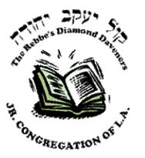
B”SD
KYY 5772
Official KYY Announcement

CHEDER MENACHEM GRADUATION

To the end the year, Cheder Menachem held their annual graduation and our Mizrach Vant 8th graders were a part of it! The two leadership medals went to Habochur Hatomim Hamispallel HaGabbai Avi Goldman and Habochur Hatomim Hamispallel HaGabbai Efraim Andrusier! This award, presented by RMD, is the epitome of what KYY stands for - training our unzerer kinder to be future leaders!

